1. Internet sockets, Unix sockets, X.25 Sockets
2. Internet sockets

- stream sockets(TCP) -> reliable two way communication, error free

- telnet

- HTTP

- datagram sockets(UDP)(connectionless)

- used when missing packets are not critical

- speed

- could not arrive

- no order

- data integrity

1. 

Hardware strips ethernet, kernel IP + UDP, TFTP program strips TFTP.

Layered Network Model(aka “ISO/OSI”)

* Application (Users interaction)
* Presentation
* Session
* Transport
* Network
* Data link
* Physical (HW, serial, Ethernet)

Unix Berkley Socets or Winsocks are >layer 5 connecting to layer 4

Unix layered model

* Application Layer (telnet, ftp)
* Host-to-host Transport layer (**TCP**, **UDP???**)

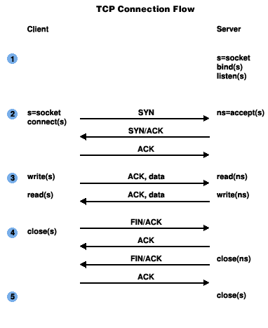

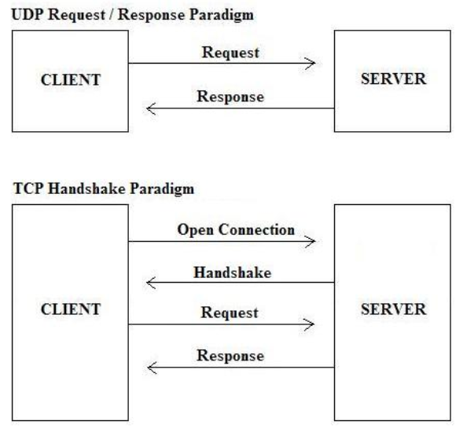

* Internet Layer (**IP and routing???**)
  + IP routing -> packet is transferred to the next network node
  + Routing Information protocol, Exterior Gateway Protocol, Border gateway Protocol
* Network access layer (Ethernet, wi-fi)

1. IP address
   1. IPv4
      1. - 192.0.2.111
      2. 32 bits
      3. Loopback : 127.0.0.1
   2. IPv6
      1. 2001:0db8:c9d2:0012:0000:0000:0000:0051
      2. 128 bits
      3. Zeroes can be collapsed
         1. 2001:0db8:ab00:0000:0000:0000:0000:0000
         2. 2001:db8:ab00::
      4. Loopback ::1
      5. COMPATIBILITY

::ffff:192.0.2.33

1. Subnets
   1. Class A – 1 byte subnet
   2. Class B – 2 byte subnet
   3. Class C – 3 byte subnet -> 256 hosts
   4. Netmask –
      1. Old style -> bitwise and with IP address to get subnet 255.255.255.0 & 192.0.2.12 -> 192.0.2
      2. New style -> 192.0.2.12/**30 – nr of network bits,** 2001:db8::/**32**
2. Port numbers
   1. Different from IP address
   2. 16 bit
   3. http 80, smtp 25, doom 666, telnet 23
3. Byte Order
   1. Big Endian -> Network Byte Order ->
   2. Little Endian -> Intel
   3. Host Byte Order, depends
   4. Care for floating numbers, 64 variant
4. Private (Disconnected) Networks
   1. NAT (Network Address Translation) -> translate “internal” IP address to “external”
   2. IPv4 –
      1. 10.0.0.x reserved
      2. 172.y.x.x -> 16 <= y <= 31 -> reserved
      3. 192.168.x.x -> 0 <= x <= 255 -> reserved
   3. IPv6 –
      1. Fdxx -> reserved
      2. Does not mix with NAT